How to Access Your Network Drives from Home

You can now access your drives at North Central College from your home if you have an Internet connection. NOTE: This system can only be used off campus.

The new system works like a library. You go to the library and check out your book. You use the book at home and then when you are finished you return the book to the library.

Your individual browser (Mozilla, IE, Fire Fox, Opera, etc.) settings are different; therefore, only general instructions can be provided. You may have blocked pop ups, or set up security so when you get those messages respond accordingly.

To access your NCC drives follow these steps:

- Type the following URL in your Web Browser https://drives.noctrl.edu . Make sure that you use https as that is a secure way to get to your files.
- You will get a screen that asks for your User Name and Password. This is identical to your network/email user name and password. After entering your user name and password, click on OK. You will get a screen that looks like the following:

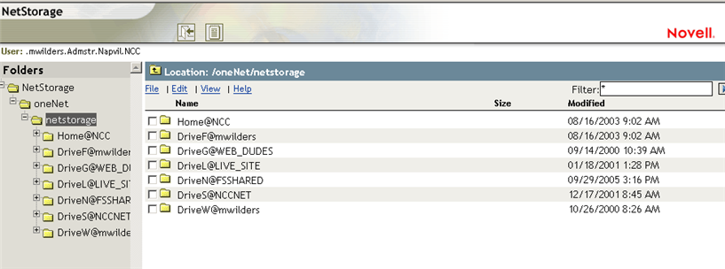
- Select the drive that you would like to use under Folders located on the left side and expand it by clicking on the + sign. Keep drilling down until the file you want to use appears on the right side. See example below.
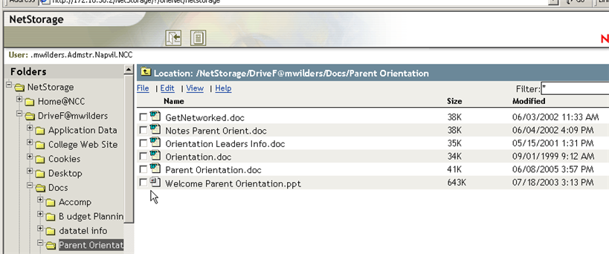
- On the right, find the document you would like to work with and place a check in the box on its left. Then double click that line and you will have the option to select Open, Save, Cancel or More Info. Save your document to your local “C” drive, the desktop or your flash drive. Do not select open as it will open your document in the browser. In essence, you have now checked the book out of the library and taken it home to work on it.
- Make sure that you save the document while you are working on it. When you have finished working on your document save it and then close the file by clicking on the close file icon on the top right (X).
- Return to the screen with all the documents listed; in our example, it would be the diagram in number 3.
- Next click on the word File which is located above the list of documents. You will see the following:
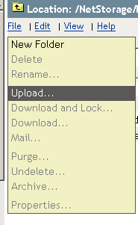

- Click on Upload. Use Browse to find the file that you want to upload and when you find it click on it. I had stored my file on my local “C” drive so my screen would look like this:
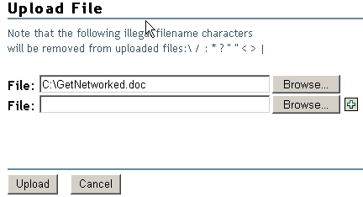

- Click on Upload. You have placed your edited file on the network drive at NCC. In essence, you have now returned your book to the library.
- Now click on the log out icon to leave the system. You will get the following message:

